TIMS: Using the Infinite Campus TIMS Extract (PreStu.csv) to Complete a Student Upload (UPSTU) into TIMS

**Within Infinite Campus**

Getting the TIMS Extract (PreStu.csv) from Infinite Campus

1. Log into Infinite Campus via NCEdCloud
2. From the Main Menu on the Left, Scroll to the Bottom and Choose System Settings
3. Then Choose Data Extract Utility under the Data Utilities Section
4. The \****NCDPI - TIMS Extract*** should be near the top of the list of Data Extract Utilities
5. Click the **\*NCDPI – TIMS Extract** and Choose TEST EXTRACT to Manually Download the File.
6. This will open a pop-up window while the TIMS Extract is being downloaded
7. Upon Completion, go to your Downloads Folder and look for PreStu.csv
8. Use the PreStu.csv File to begin the UPSTU Process within TIMS

**Within TIMS**

Using the PreStu.csv File to Complete a TIMS UPSTU

1. Move the PreStu.csv File to the Elt\DatabaseName\Server\DYN folder of the correct TIMS Database.
2. Rename the file from PreStu.csv to PreStu.Dat

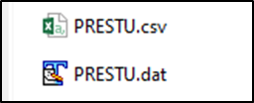

1. Open the Edulog Maintenance Utility (EMU) for the TIMS Database
2. Stop Tomcat
3. Run the **PreStu – Create NewStu** EMU Batch
   1. This EMU Batch will read the PreStu.Dat file and create NewStu.Dat inside DYN
   2. This EMU Batch will then copy the NewStu.Dat file from DYN to the Export Folder

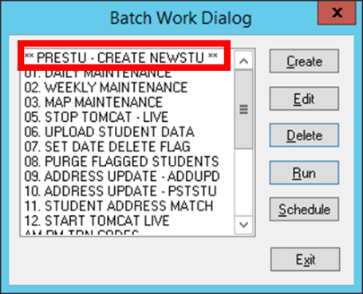

1. After **PRESTU- Create NewStu** completes, check the Server\Export Folder for the latest NewStu.dat file

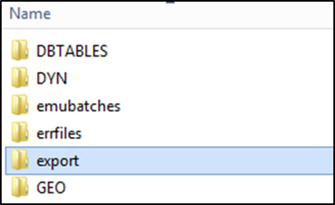 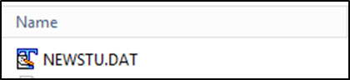

1. If present, complete UPSTU Steps as Normal* within your LEA
   1. *Some LEAs add\remove records, Combine Files from Multiple Sources or edit the NewStu File for special assignments prior to UPSTU within TIMS
   2. *If so, can copy the Server\Export\NewStu.dat file… rename it to NewStu.txt and use it for any traditional editing procedures within your LEA.