**How to Import\Back Load TIMS Bus Assignment Information into Infinite Campus.**

Before Beginning the Import\Back Load of TIMS Data into Campus, TIMS Staff will need to Run the TIMS Report and Format the File to meet Campus Import Specifications.

Please refer to those instructions found at NCBusSafety.Org

1. Log into Infinite Campus via NCEdCloud
2. From the Main Menu on the Left, Scroll to the Bottom and Choose System Settings
3. Then Choose Data Import Wizard under the Data Utilities Section

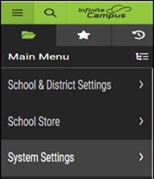 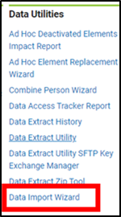

1. Under Import Type – choose the TIMS BUS IMPORT
2. Under Layout – choose TIMS if not already selected

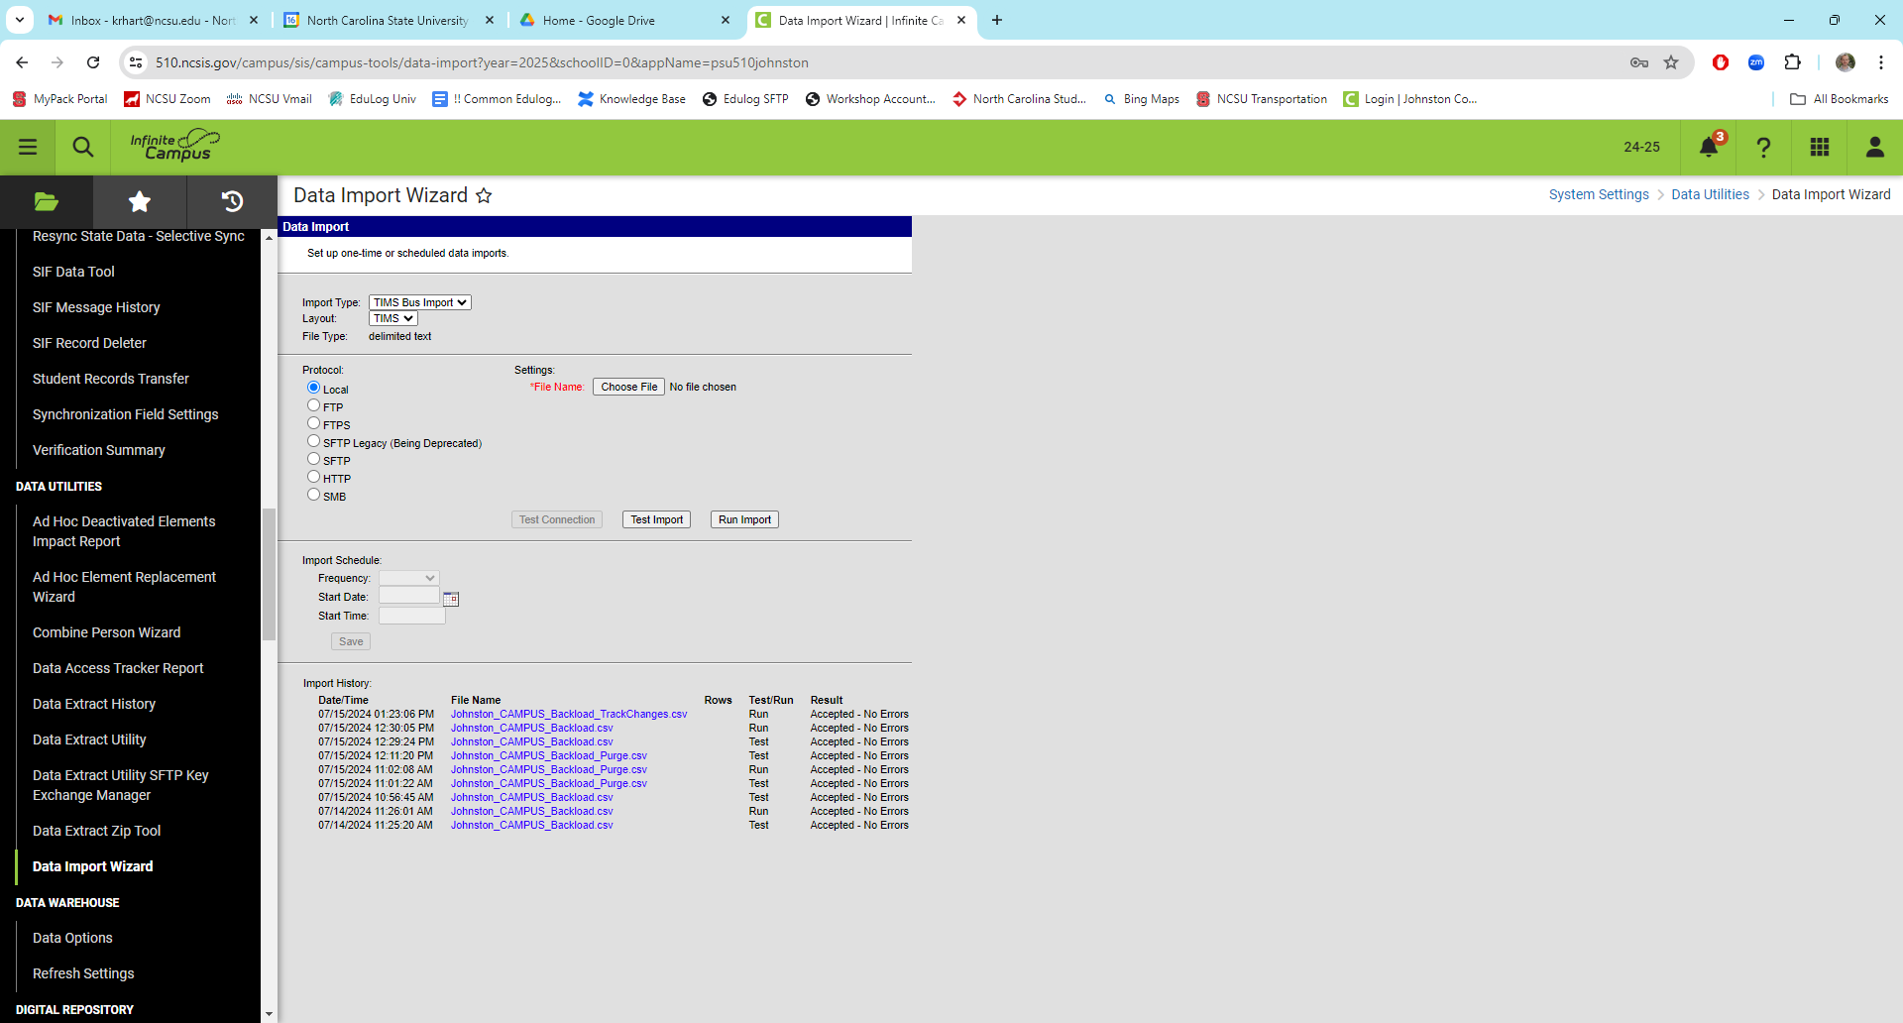

1. Click Choose File and Select the TIMS File containing the formatted Bus Stop Information to be imported into Campus.
2. Users can then TEST IMPORT prior to the actual update of the Data.

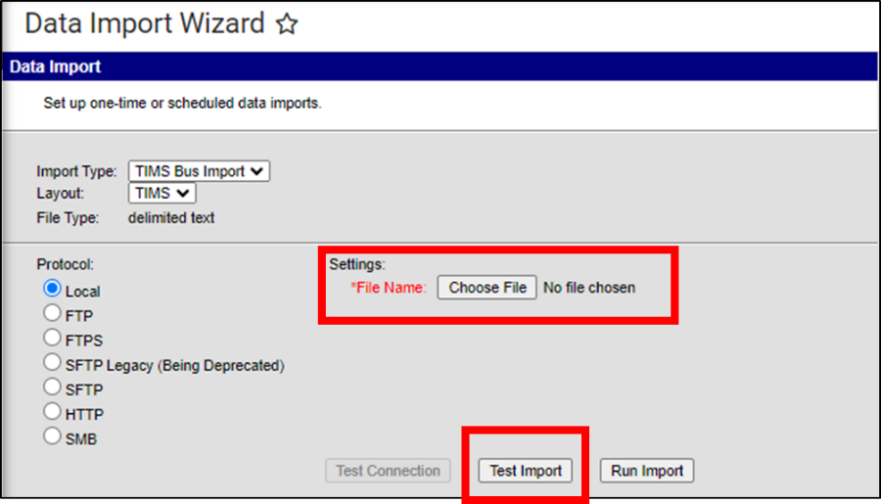

1. When the TEST IMPORT or RUN IMPORT is completed, there will be an Output Log under Import History than can be reviewed. Click the Link under FILE NAME in the Import History Section.

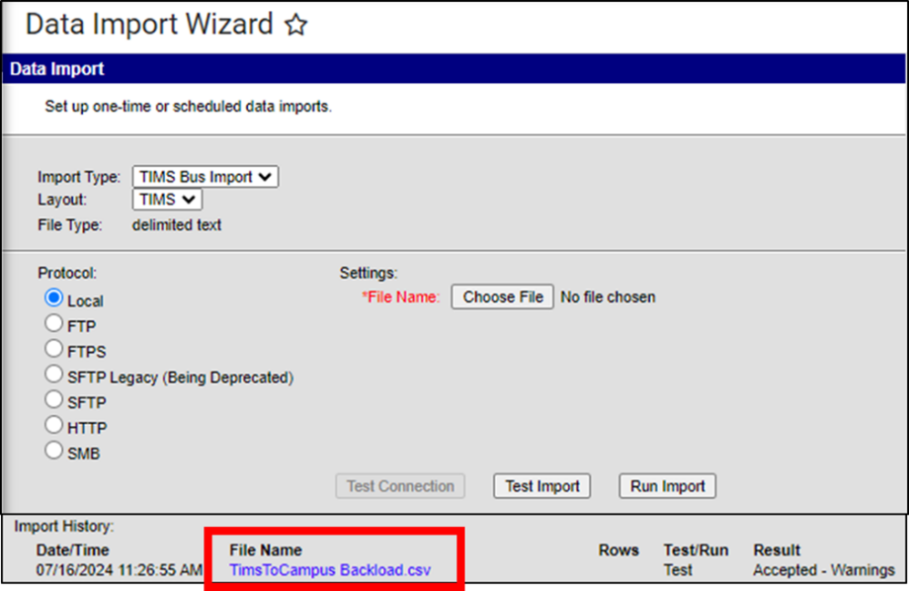

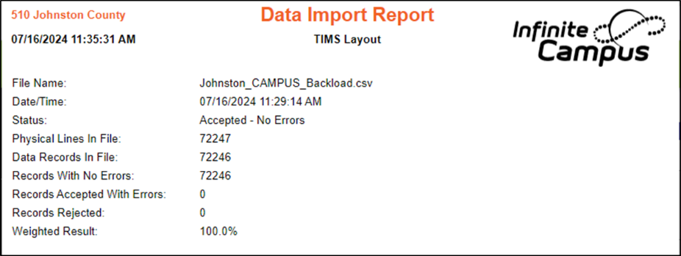

1. If a TEST IMPORT was completed in Step 8, re-select the file and choose RUN IMPORT to perform the actual update to Student Bus Information within Campus.

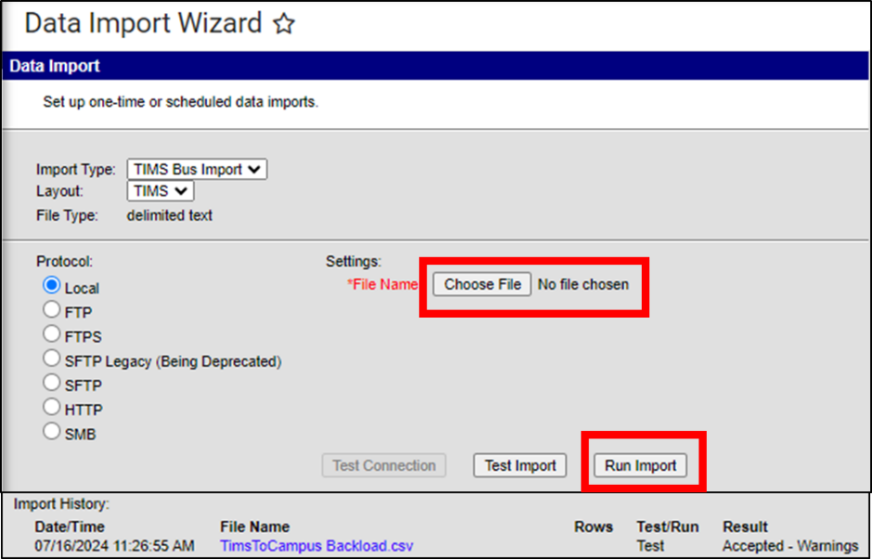

1. Upon Completion of RUN IMPORT, the TIMS School Bus Data from the File will be imported onto the Student Transportation Screen and Viewable within Infinite Campus.

**Today’s Busing**

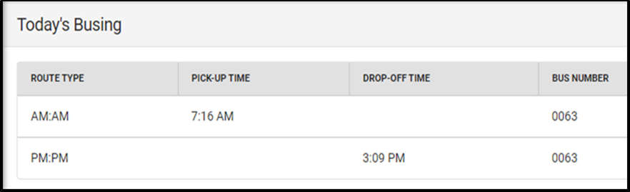

**Additional Information Available in the Route Details Section of Each TIMS Assignment.**

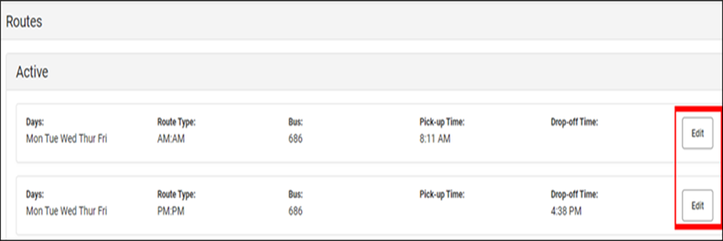

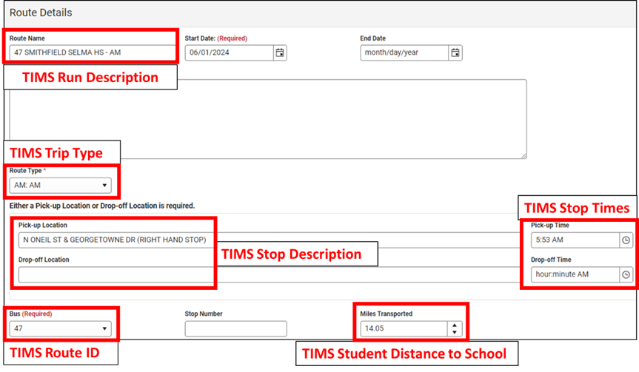

**If your LEA is not currently using the SIS Transportation Screen to Manage Bus Stop Requests or Import TIMS Assignment Data… but are interested in implementing these features of TIMS & Infinite Campus, please have local Transportation Staff contact TIMS Project Leaders at North Carolina State University or UNC Charlotte.**

**TIMS Support Staff can advise you on the best approach to begin implementing these features within your LEA.**