**How to Download of the TIMS Extract from Infinite Campus.**

1. Log into Infinite Campus via NCEdCloud
2. From the Main Menu on the Left, Scroll to the Bottom and Choose System Settings
3. Then Choose Data Extract Utility under the Data Utilities Section

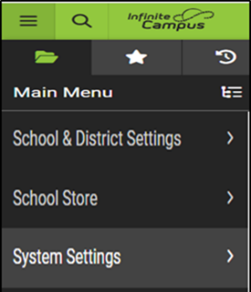 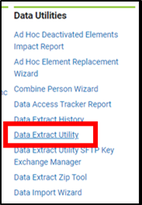

1. The \****NCDPI - TIMS Extract*** should be near the top of the list of Data Extract Utilities
2. Click the *NCDPI – TIMS Extract and Choose TEST EXTRACT to Manually Download the File

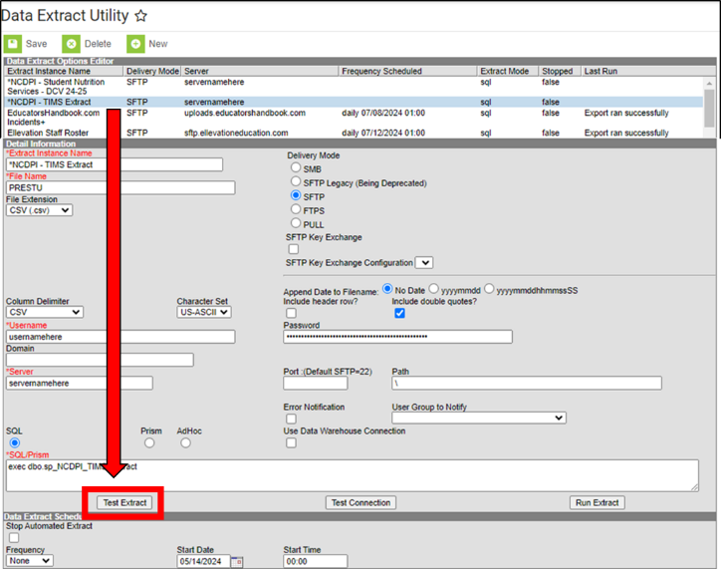 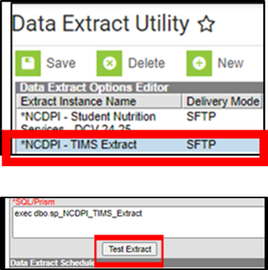

1. This will open a pop-up window while the TIMS Extract is being downloaded
2. Upon Completion, go to your Downloads Folder and look for PreStu.csv
3. Use the PreStu.csv File to begin the UPSTU Process within TIMS

