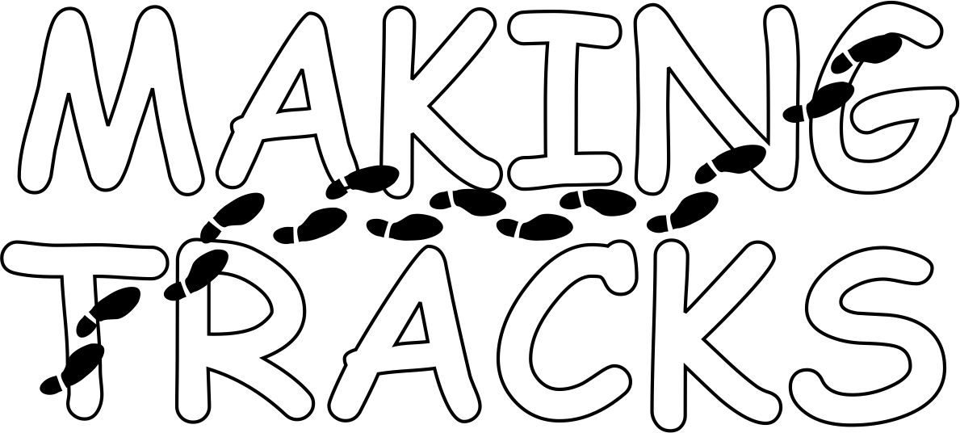
Video Contest – Registration Form

The Transportation Services section at the North Carolina Department of Public Instruction is conducting a Youth Video Contest entitled “Making Tracks” that is open to middle and high school students across the state. The purpose of the video contest is to help students understand the importance of pedestrian safety to and from school and, in particular, to and from the bus. Students will create 2 minute videos that highlight areas of safety that concern them in their own communities daily. To enter the contest, upload video, and vote for the winners log on to www.ncbussafety.org/makingtracks. You must also submit this registration form, as indicated below.

* Team Leader / Name of Person Submitting Video * Title of Video

* Email address of Person Submitting Video * Grade of Team Leader
*Date of Birth of Person Submitting Video
Month: | Day: | Year:
*Team Member(s)
Name | Grade

PAGE 1 of 2

*Name of School
*Name of Faculty Sponsor
*Faculty Sponsor Contact Phone Number
*Faculty Sponsor Email Address

* Team Members T-Shirt Sizes
T-Shirt Size | Number of Participants
Small
Medium
Large
XL
XXL
Total Team Members
*A parent or guardian must provide permission to submit this video for public use. Please have a parent or guardian sign the media release permission form for any team member who appears in the video or whose name appears in the video. Your video will not be accepted without the completed media release permission form.
* required fields
Completed forms should be forwarded to: Derek Graham
NCPDI Transportation Services Section
6319 Mail Services Center
Raleigh, NC 27699-6319
Phone: (919) 807-3570

FAX: (919) 807 – 3578
Email derek.graham@dpi.nc.gov

PAGE 2 of 2

