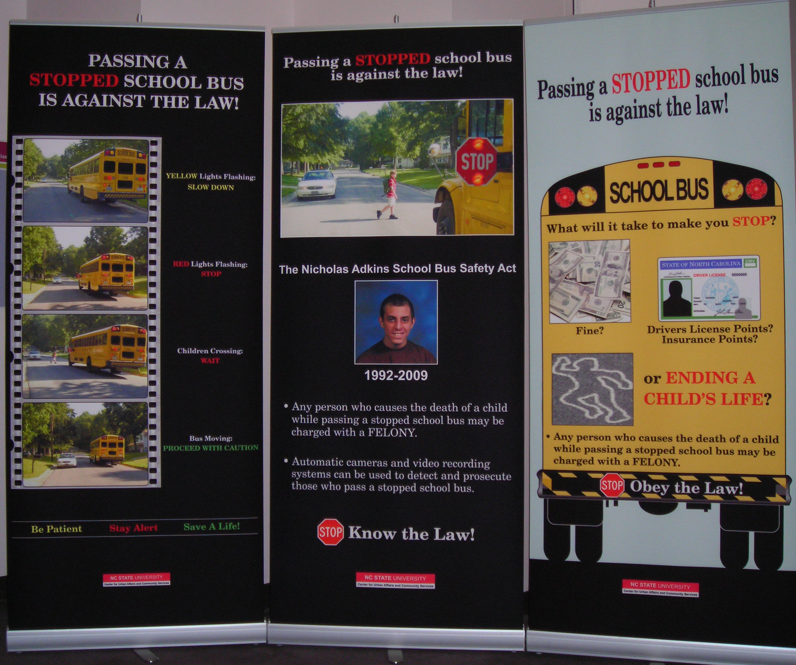

STOP ARM VIOLATION
PUBLIC AWARENESS BANNERS
LOAN / USE FORM

Preferred Set:
_____Set A: Banners #1 and #2
_____Set B: Banners #1 and #3

REQUEST
School district / organization requesting: ____________________

First date needed: ________ Last date needed: _______________

Planned use: __________________________________________

_____________________________________________________

REPORTING
Results / estimated attendance / etc.:
_______________________________________________________

_______________________________________________________

_______________________________________________________

Please email pictures to jstrickl@dpi.state.nc.us or dgraham@dpi.state.nc.us

