Instructions for 2020-2021 TDTIMS Submission
Due: on or before June 30th, 2021
Please PRINT and READ all instructions BEFORE doing anything.
After performing the TIMS data reviews and corrections outlined in the Preparing for 2020-2021 TDTIMS document, complete the steps below to submit TDTIMS. Please contact TIMS Support Staff at NCSU-ITRE or UNC Charlotte if you have any questions or need assistance in completing the submission.

- Set up the TDTIMS File Folder
- On the C: Drive of the TIMS Server is a folder named TDTIMS that is typically used each year.
- LEAs on a new or different TIMS server since November 2019 may need to create this folder (C:\TDTIMS)
- If the C:\TDTIMS folder already exists, go inside the folder and delete any and all files. This file folder must be empty to begin.

- Inserting the TDTIMS Workbook
- TIMS Support Staff have distributed the 20202021_TDTIMS_May workbook to each LEA.
- Please download, move or save the Workbook to the TIMS Server and place it inside the empty C:\TDTIMS folder.

Note: If you need to submit data from more than one dataset, such as SN data or Cohort B information, you will need to create a new empty TDTIMS folder to begin again, after completing all steps for the first TIMS database.

- Complete the TDTIMS Workbook
- To complete the workbook, you will need the final TD2 and TD2R Reports submitted to DPI
- The 2020-2021 TDTIMS Workbook is different from normal.
  - It collects minimal information about the LEA and only compares Total Buses and Total Riders between TIMS and the TD2\TD2R Reports.
- Open the Workbook and fill in all cells highlighted in yellow.
  - For the number of Routes and Riders in TIMS, use these reports to acquire the info
    - User Defined Reports >Stops, Runs Routes > Workbook: Route Count
    - User Defined Reports > Bus Passes > Workbook: Count of Valid Riders
  - If operating in Plan A, only complete the Comparison Section for Plan A.
    - If SN Data is managed within LIVE Data, enter Zero (0) for separate SN values.
    - If you manage SN separately, enter the Route Count and Valid Riders from this dataset in the workbook. LEAs with SN Data should be familiar with these steps.
  - If operating in Plan B, LEAs may need to complete additional Comparison Sections, one for each ABC Cohort Group.
    - LEAs operating under Plan B should contact TIMS Project Leaders to discuss the status of the TD2\TD2R Reports and the Management of TIMS Data.
    - TIMS Support Staff understand there may be data management irregularities and can help determine the best approach to submitting TDTIMS for Plan B
- Enter the Total Buses and Assigned Riders from TIMS and the Daily Routes and Headcount Totals from the TD2\TD2R into the Workbook to calculate the TDTIMS Percentage Comparison.
  - Ideally, Bus Routes should match 100% and Bus Riders should be slightly above 100%.
  - During normal years, TIMS Bus Riders must be at least 90% of the Headcount Total
  - LEAs are encouraged to submit the most accurate data possible but do not have to meet 90% Minimal Requirements for the 2020-2021 TDTIMS Submission.

After filling out the TDTIMS Workbook, print a copy for your records then Save and Close the file.
You are now ready to Generate TDTIMS Reports.

- Open Edulog Reports for the TIMS Data you wish to submit.
- TIMS Operators will manually run each of the TDTIMS Reports for the 2020-2021 Submission.
- Step by Step Instructions are detailed below.
- Feel free to contact TIMS Support Staff if you have questions or need assistance along the way. We would rather help you the first time around than help you resubmit TDTIMS.

- ______ Run the following reports:

From the Edulog Reports Main Menu:

______Choose RR Crossing button. Perform the following steps outlined in red:

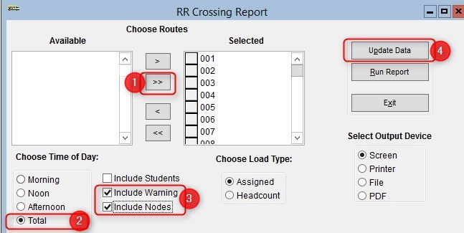
When ‘Done Processing’, exit back to the Reports Main Menu.

______ Open the Student Ride Times section of Reports (upper right of reports main menu)
First click the Update Data Button (upper right of Student Ride Times section)
Make Sure Output Device is set to Screen (lower right)
Then select the Riders Report button (upper right below Update Data)
Close the Print Preview of the Riders Report
NEXT: Follow the steps below to generate the Student Ride Times Report

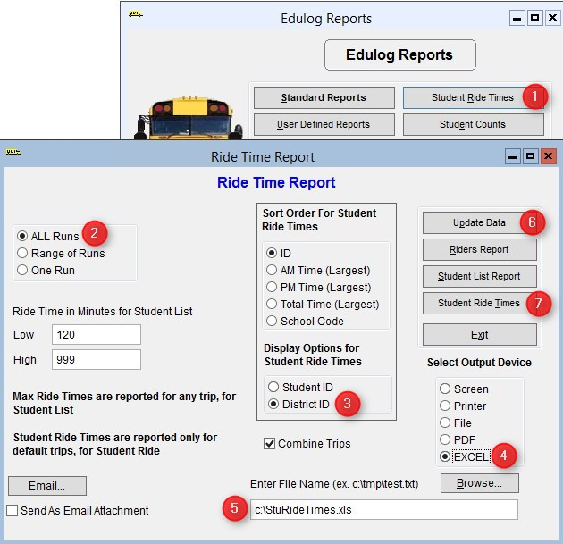
C:\TDTIMS\StuRideTimes.xls

Numbers below correspond to the Red numbers in the diagram:

- From Reports Menu, select Student Ride Times button
- Choose All Runs
- Choose District ID under Display Options
- Choose Excel as the Output Device
- Enter the output path as C:\TDTIMS\StuRideTimes.XLS
(double check spelling!)
- Click Update Data
- Click Student Ride Times to create the report

- ______ Operators will manually generate each TDTIMS report listed below. All reports are located
in the User Defined Reports section: Select each report and click the Run Report
button. No need to view the report if prompted.

For TIMS-SQL, Operators need to verify the Output Path is present for each TDTIMS Report.
As you select each report, glance at the bottom of the menu and make sure the report is set to a FILE Output and the output path is shown is pointing to the C:\TDTIMS folder.
If the report path is missing, contact TIMS Support Staff.

For TIMS-NT, we are not using the TDTIMS Processor this year and TIMS Support Staff may need to import TDTIMS Reports into the different databases being managed by LEAs for Plan A or Plan B. Once TDTIMS Reports have been imported and are available to TIMS-NT Sites, the Output Path should be correct for all reports. LEAs operating TIMS-NT should contact TIMS Project Leaders to ensure they have all TDTIMS Reports available and are ready to begin.

TDTIMS Reports are located in the USER DEFINED REPORTS section of TIMS

______ Schools > -TDTIMS: Boundaries Archive
______ Schools > -TDTIMS: Clusters Archive (Note: most LEAs will have no results)
______ Schools > -TDTIMS: Schools Archive

______ All Students and Transportation > Duke Report
______ All Students and Transportation > TDTIMS: Min/Max for Submission

______ Stops, Runs Routes > TDTIMS: AM ARRIVAL ARCHIVE
______ Stops, Runs Routes > TDTIMS: PM School Services Archive
______ Stops, Runs Routes > TDTIMS: Route Count
______ Stops, Runs Routes > TDTIMS: Route Time and Miles Submit
______ Stops, Runs Routes > TDTIMS: Runs and Routes Archive
______ Stops, Runs Routes > TDTIMS: Services and Stops Archive

______ Bus Passes > TDTIMS: ALL STUDENTS ARCHIVE
______ Bus Passes > TDTIMS: All Rider Distances
______ Bus Passes > TDTIMS: Count of Valid Riders
______ Bus Passes > TDTIMS: RIDERS ARCHIVE
______ Bus Passes > TDTIMS: Student Archive
______ Bus Passes > TDTIMS: Student Transportation Archive
When Finished Generating All TDTIMS Reports, close the reports module and open the C:\TDTIMS folder.
TIMS Operators should have 18 Files inside the TDTIMS Folder. (19 Files if using Cluster Schools in TIMS)

- _____ Open QMF_RCNT report in Textpad – this should match the number of TIMS Routes reported in the Workbook.
- _____ Open QMF_RIDE report in Textpad – this should match the number of TIMS Riders reported in the Workbook.
If QMF_RCNT and QMF_RIDE match the Workbook Values, proceed to Step 9.
If not, Update the Workbook to Match or Contact TIMS Support for Assistance.

- _____ Rename All Files (except the TDTIMS Workbook)
- Include the 3-digit LEA Code and TIMS Database name at the end of each file.
  - (before the .txt .xls or .csv extensions)
- Please use an underscore ( _ ) to separate the LEA Code and Database Name

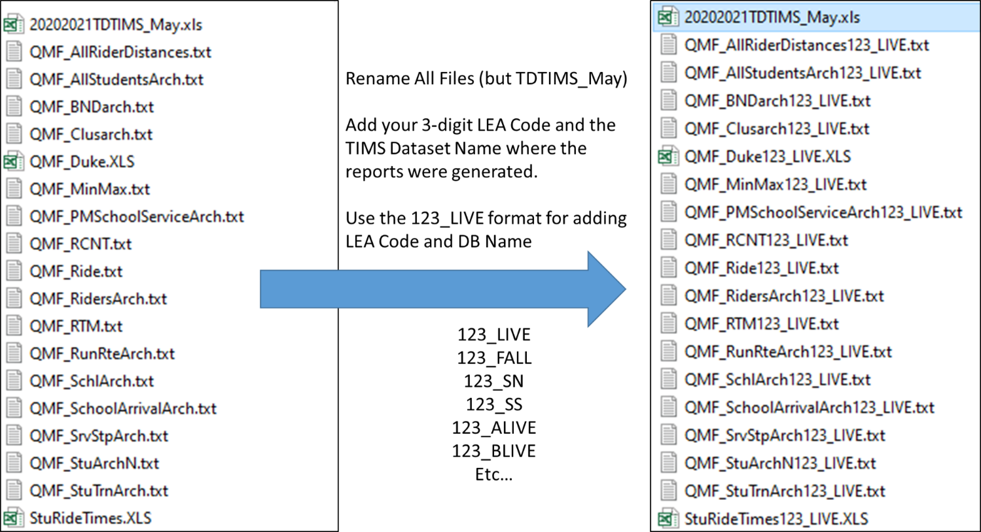

- _____ Rename the TDTIMS Folder
- When Finished, return to the root of C:\ and rename the TDTIMS folder.
  - Add 2021_XXX_LIVE to the folder name, where XXX is your LEA Code and LIVE is the TIMS Dataset name. Examples Below
    - TDTIMS2021_123_LIVE
    - TDTIMS2021_123_FALL
    - TDTIMS2021_123_SN

- ______ Freeze Work and Contact TIMS Support Staff
- Please contact TIMS Support and freeze TIMS Data updates and changes in the TDTIMS Dataset just completed.
- Because of the irregularities this year, TIMS Support Staff will need to manually move a few files to the TDTIMS Folder before you are completed.
- Support Staff will also review your work as part of this process and make sure the data matches, all files are present and the submission is finalized.

- _______ Make a Backup of the TDTIMS Dataset
- For TIMS-SQL, make an Archived Backup and add 2020-2021 TDTIMS as the Backup Description
- For TIMS-NT, make a normal backup and add 20202021TDTIMS as the Backup Description.
  - Note: Backups made for TIMS-NT cannot have spaces in the description.
- TIMS Support Staff will also move the backup to the TDTIMS Folder are part of final data steps.

- _______ Create a new empty TDTIMS folder on the C: Drive of the TIMS Server (C:\TDTIMS)
- If the LEA manages LIVE and SN Data together and operating under Plan A, TDTIMS is Complete!
- If the LEA manages separate SN or Plan B Cohort Data, return to Step 4 and generate TDTIMS Reports for the next TIMS Dataset.

TIMS Project Leaders would like to check your data as soon as possible.

This will prevent having to restore data or rerun a report that was missed.

Please do not move forward with route updates and changes until TIMS Project Leaders have verified everything is present and correct with TDTIMS.

Once you get the “All Clear”, TDTIMS will be complete and LEAs can focus on Summer School and Fall Planning.

